Chapter 1: Structure Determines Properties

1. | What is the ground state electron configuration of carbon?
 | A) 1s²2s²2p_{x}¹ B) 1s²2s²2p_{x}² C) 1s²2s²2p_{x}¹2p_{y}¹ D) 1s²2s²2p_{x}²2p_{y}¹
 | Ans: C

2. | Which of the following has (have) the same electron configuration as Ne?  Na⁻ Mg²⁺ O²⁻ Mg⁺
 | A) Na⁻ and O²⁻ B) Mg²⁺ and O²⁻ C) Mg⁺ and O²⁻ D) only Mg²⁺
 | Ans: B

3. | What is the letter designation given to dumbbell shaped orbitals like the one depicted below?  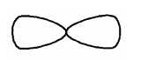
 | A) s B) p C) d D) f
 | Ans: B

4. | What is the charge on the phosphorus ion in Na₃P?
 | A) -3 B) -1 C) +1 D) +3
 | Ans: A

5. | Predict which bond is the most polar in ethanol, CH₃CH₂OH?
 | A) C—C B) C—H C) C—O D) O—H
 | Ans: D

6. | Which one of the following is the conjugate base of NH₃?
 | A) NH₄⁺ B) H⁺ C) N³⁻ D) NH₂–
 | Ans: D

7. | Which one of the following is the ionic compound formed between magnesium and chlorine?
 | A) MgCl B) MgCl₂ C) Mg₂Cl₃ D) MgCl₃
 | Ans: B

8. | Identify the condensed formula of the following structure:  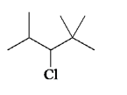
 | A) | (CH₃)₂CHCHClCH(CH₃)₂ | C) | (CH₃)₂CHCHClC(CH₃)₃
 | B) | CH₃CH(CH₃)CHClCH(CH₃)₂ | D) | (CH₃)₃CCHClCH(CH₃)₃
 | Ans: C

9. | What is the chemical formula of the following carbon skeleton diagram?  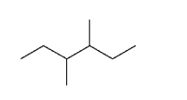
 | A) C₈H₁₄ B) C₈H₁₆ C) C₈H₁₈ D) C₈H₂₀
 | Ans: C

10. | How many hydrogen atoms are there on carbon atoms 1 and 2, respectively, in the structure below?  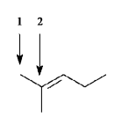
 | A) 4, 1 B) 4, 0 C) 3, 1 D) 3, 0
 | Ans: D

11. | How many C₃H₈O constitutional isomers are possible?
 | A) one B) two C) three D) four
 | Ans: C

12. | Which of the following best describes the relationship between the following two structures?  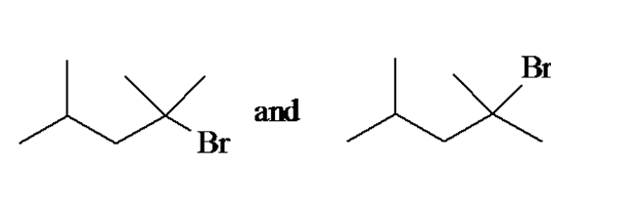
 | A) | identical compounds
 | B) | resonance structures
 | C) | constitutional isomers
 | D) | different compounds with different constitutions
 | Ans: A

13. | How many constitutional isomers of C₄H₉Br are possible?
 | A) one B) two C) three D) four
 | Ans: D

14. | How many constitutional isomers of C₃H₆Cl₂ are possible?
 | A) three B) four C) five D) six
 | Ans: B

15. | What is the formal charge on the carbon atom?  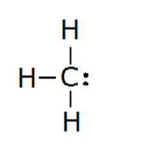
 | A) +1 B) 0 C) -1 D) -2
 | Ans: C

16. | Which of the following describes the relationship between the following two structures?  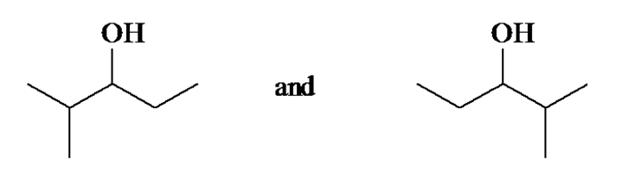
 | A) | identical structures
 | B) | resonance forms
 | C) | constitutional isomers
 | D) | different compounds with different compositions
 | Ans: A

17. | Which of the following describes the relationship between the following two ions?  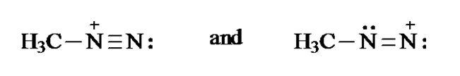
 | A) | identical structures
 | B) | resonance forms
 | C) | constitutional isomers
 | D) | different compounds with different compositions
 | Ans: B

18. | What is the formal charge on the oxygen atom in the structure below?  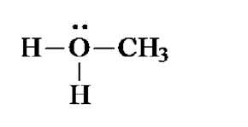
 | A) -1 B) 0 C) +1 D) +2
 | Ans: C

19. | What is the formal charge on the nitrogen atom in the structure below?  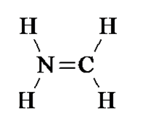
 | A) -1 B) 0 C) +1 D) +2
 | Ans: C

20. | The formal charges on the nitrogen and oxygen in the following structures are, respectively  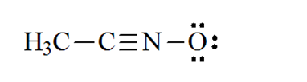
 | A) +1, -1 B) 0, -1 C) +1, 0 D) 0, 0
 | Ans: A

21. | In which of the following compounds would you expect Cl to have a partial positive charge?
 | A) HCl B) CCl₄ C) NaCl D) HOCl
 | Ans: D

22. | Based on the VSEPR model, which of the following species has (have) a trigonal planar geometry?  I. BCl₃ II. NH₃ III. NO₃¯
 | A) only I B) I and II C) I and III D) I, II, and III
 | Ans: C

23. | Based on VSEPR theory, which of the following species has (have) a trigonal pyramidal geometry?  I. CO₃²⁻ II. NH₃ III. CH₃⁺
 | A) only I B) only II C) I and II D) II and III
 | Ans: B

24. | Which of the following species has(have) a linear geometry?  I. CO₂ II. NO₂⁺ III. NO₂¯
 | A) only I B) only II C) I and II D) I, II, and III
 | Ans: C

25. | Which of the following molecules would you expect to have a dipole moment?  I. CO₂ II. HCN III. CHCl₃
 | A) II and III B) only II C) only III D) I, II, and III
 | Ans: A

26. | Which of the following molecules would you expect to have a dipole moment?  I. CH₂Cl₂ II. CH₃Cl III. CCl₄
 | A) only I B) only II C) I and II D) I, II, and III
 | Ans: C

27. | The H—C—H bond angles in ethylene, C₂H₄, are closest to
 | A) 90°. B) 109.5°. C) 120°. D) 180°.
 | Ans: C

28. | The C—C—C bond angle in propane, C₃H₈, is closest to
 | A) 90°. B) 109.5°. C) 120°. D) 180°.
 | Ans: B

29. | What are the formal charges of boron and nitrogen, respectively, in the following structure?  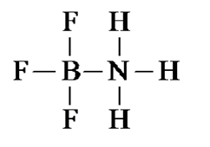
 | A) -1 and +1 B) -1 and 0 C) 0 and +1 D) 0 and 0
 | Ans: A

30. | Which one of the following is isoelectronic with CO₂?
 | A) NO₂¯ B) NO₂⁺ C) NO₂ D) O₃
 | Ans: B

31. | In which of the following does hydrogen have a partial negative charge based on electronegativity?
 | A) BH₃ B) CH₄ C) NH₃ D) H₂O
 | Ans: A

32. | Which of the following species have a zero formal charge on its carbon atom?  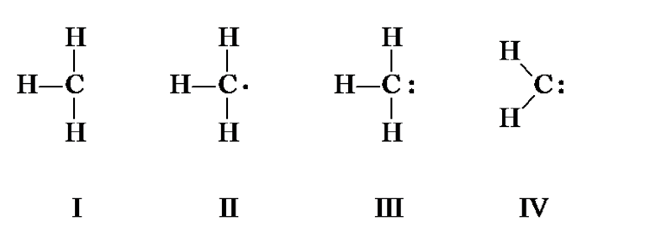
 | A) I and II B) II and IV C) III and IV D) I, II, and III
 | Ans: B

33. | Which one of the following species is formed when diazomethane loses a nitrogen molecule?  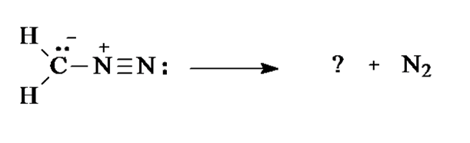  diazomethane  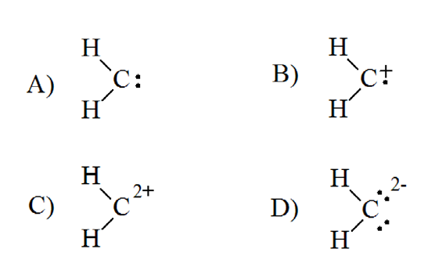
 | A) A B) B C) C D) D
 | Ans: A

34. | Which species is formed when the CH₃N₂⁺ cation loses a nitrogen molecule?
 | A) A B) B C) C D) D
 | Ans: A

35. | Give the molecular formula of the compound shown below:  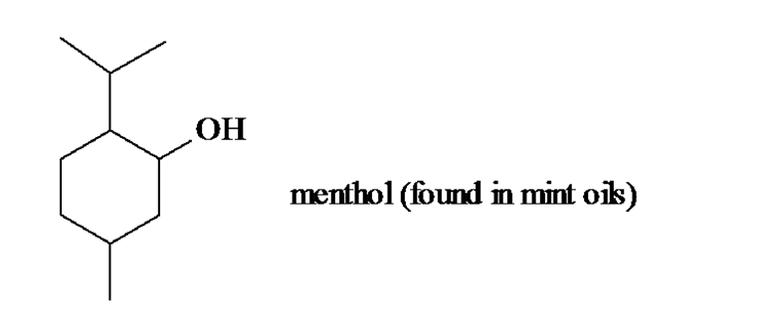
 | A) C₈H₁₆O B) C₉H₁₈O C) C₁₀H₁₈O D) C₁₀H₂₀O
 | Ans: D

36. | The electron pair movement depicted below produces a second resonance form for the species. What is the formal charge on the nitrogen atom for this second resonance form?  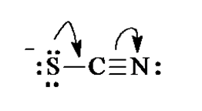
 | A) -2 B) -1 C) 0 D) +1
 | Ans: B

37. | Which statement correctly describes the structures of BH₃ and NH₃?
 | A) | Both are trigonal and planar.
 | B) | Both are pyramidal.
 | C) | BH₃ is trigonal planar and NH₃ is trigonal pyramidal.
 | D) | BH₃ is trigonal pyramidal and NH₃ is trigonal planar.
 | Ans: C

38. | Which one of the following is the conjugate acid of ethanol?
 | A) CH₃CH₂O– B) CH₃CH₂O⁺ C) CH₃CH₂OH₂⁺ D) CH₃CH₂OH₃⁺
 | Ans: C

39. | In the equilibrium below, the strongest base is:  (pK_{a} H₂O = 15.7, pK_{a} NH₃ = 36)  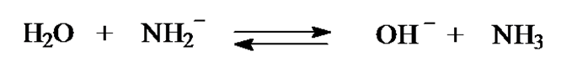  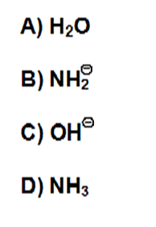
 | A) A B) B C) C D) D
 | Ans: B

40. | In the equilibrium below, the strongest acid is:  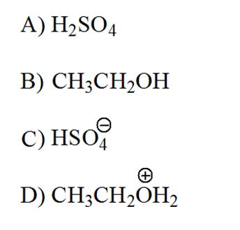
 | A) A B) B C) C D) D
 | Ans: A

41. | Which one of the following is the strongest base?  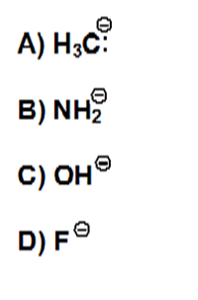
 | A) A B) B C) C D) D
 | Ans: A

42. | Which one of the following mechanistically depicts the protonation of methanol by hydrogen bromide?  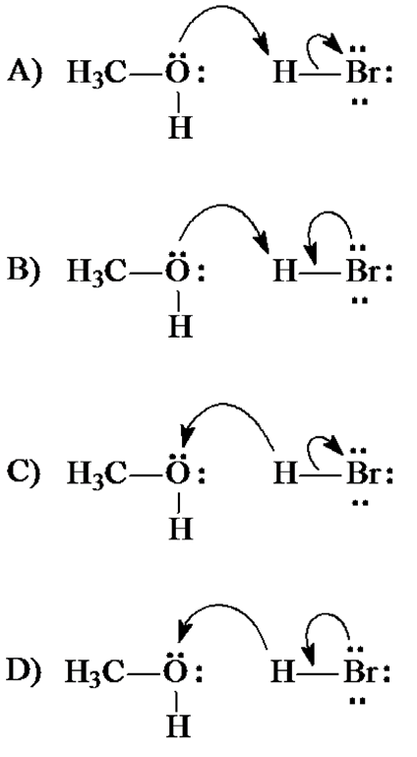
 | A) A B) B C) C D) D
 | Ans: A

43. | Which one of the following is the strongest acid?
 | A) FCH₂CO₂H B) ClCH₂CO₂H C) BrCH₂CO₂H D) ICH₂CO₂H
 | Ans: A

44. | Which one of the following has the largest acid equilibrium constant, K_{a}?
 | A) CH₃CO₂H B) CH₂ClCO₂H C) CHCl₂CO₂H D) CCl₃CO₂H
 | Ans: D

45. | For which of the following does the equilibrium favor reactants.  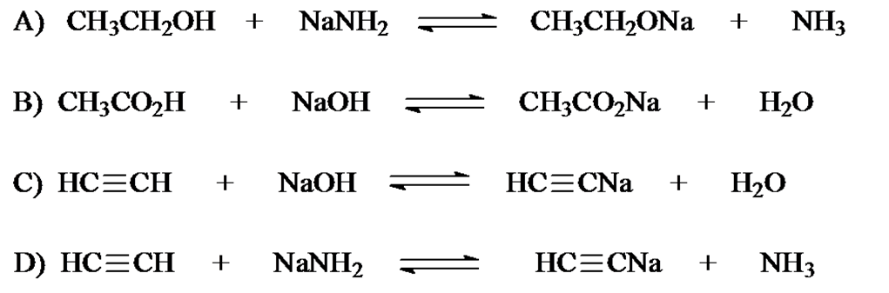
 | A) A B) B C) C D) D
 | Ans: C

46. | Identify the resonance structure which results from the following "electron pair movements".  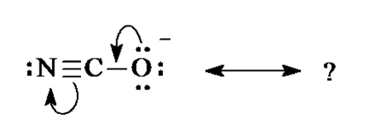  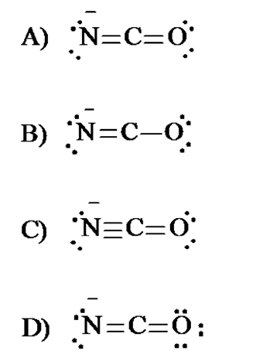
 | A) A B) B C) C D) D
 | Ans: A

47. | A Lewis structure of the azide ion, N₃¯, is shown below. The formal charge on the middle nitrogen atom is:  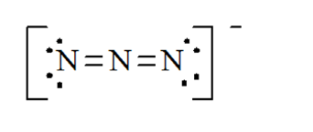
 | A) +2 B) +1 C) 0 D) –1
 | Ans: B

48. | Identify the species which results from the following movement of electron pairs.  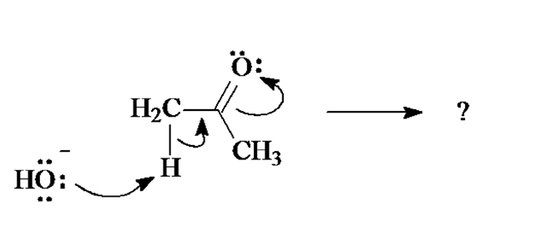  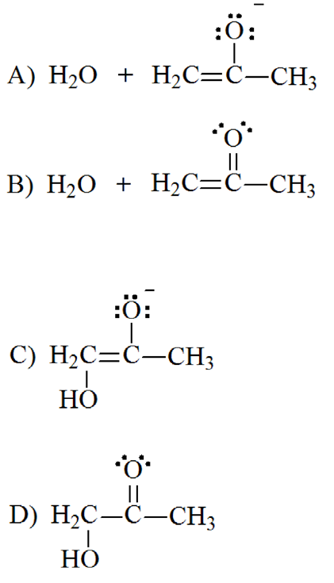
 | A) A B) B C) C D) D
 | Ans: A

49. | The most stable resonance contributor of this would be:  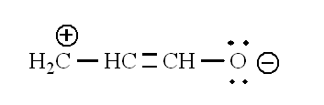  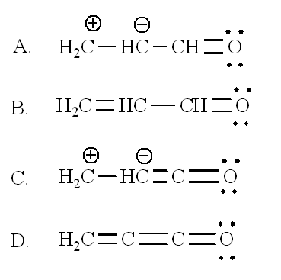
 | A) A B) B C) C D) D
 | Ans: B

50. | What is the molecular formula of aspirin?
 | A) C₆H₄O₄ B) C₈H₈O₄ C) C₉H₈O₄ D) C₉H₁₀O₄
 | Ans: C

51. | Which of the following is not identical to the others?
 | A) A B) B C) C D) D
 | Ans: D

52. | Which of the line-bond structures below cannot represent a stable molecule?
 | A) A B) B C) C D) D
 | Ans: C

53. | Which of the electron-movement arrows below are NOT valid?
 | A) A B) B C) C D) D
 | Ans: C

54. | What atom would have a formal charge in this structure?
 | A) A B) B C) C D) D
 | Ans: D

55. | Rank the following in order of decreasing acidity. (more acidic > less acidic)
 | A) | I > IV > III > II | C) | IV > I > II > III
 | B) | III > II > I > IV | D) | I > III > IV > II
 | Ans: A

56. | Using resonance principles, what atom is acid first protonated in the molecule shown?
 | A) A B) B C) C D) D
 | Ans: B

57. | What structure would result from these electron movement arrows?
 | A) A B) B C) C D) D
 | Ans: C

58. | What would be the line-bond structure for (CH₃)₃CCH₂CH(CH₃)₂?
 | A) A B) B C) C D) D
 | Ans: A

